
Q&A Chatbot using RAG Architecture

Skills take away From This Project | - Natural Language Processing (NLP) – preprocessing, embeddings, retrieval-augmented generation  - Text Cleaning & Preprocessing – chunking, regex, stopword removal  - Feature Engineering – Sentence Transformers, BERT embeddings  - RAG Architecture – Retrieval, Augmentation, Generation with LLMs  - Vector Databases – Chroma, FAISS for semantic search  - Deep Learning for Text – Transformer models (Llama, GPT), Pre-trained models  - Model Optimization: Prompt engineering, reranking, handling query ambiguity  - Explainability & Interpretability – Source citation, attention maps  - Deployment – Streamlit web app in AWS EC2
Domain | NLP, AI, Information Retrieval, Knowledge Management, Chatbots, AI for Productivity

Problem Statement:

Users face challenges in quickly extracting information from large documents or knowledge bases. The goal is to develop and deploy a Retrieval-Augmented Generation (RAG) chatbot that retrieves relevant context from documents and generates accurate, grounded answers using NLP techniques, served via a simple web app.

Business Use Cases:

Customer Support: Automated Q&A from product manuals or FAQs.

Legal Firms: Querying and summarizing contracts or case files.

Education: Answering student questions from textbooks or lecture notes.

Enterprises: Internal knowledge base search for employee queries.

Research: Extracting insights from academic papers or reports.

Approach:

1. Data Pipeline
- Document ingestion: Load PDFs, text files, or web content.
- Chunking & Preprocessing: Split into semantic chunks, clean text (remove punctuation, URLs, etc.).

2. Feature Engineering
- Embeddings: Generate vector representations using Sentence Transformers or BERT.

3. Modeling
- Vector Store: Index embeddings in Chroma or FAISS for fast retrieval.
- Retrieval: Semantic search to fetch top-k relevant chunks.
- Generation: Augment LLM prompts with retrieved context (using models like Llama or GPT).

4. Model Selection
- Compare basic RAG vs. advanced (e.g., with reranking).

5. Explainability
- Display retrieved document sources and relevance scores.
- Attention heatmaps for LLM outputs.

6. Evaluation
- Handle diverse queries (e.g., multi-hop questions).

7. Deployment
- Save the RAG pipeline (pickle or ONNX).
- Create a Streamlit web app for uploading documents and querying → response with sources. Deploy on AWS EC2.

Results
- RAG Chatbot with >80% response relevance and low hallucination.
- Comparison between different embedders, vector DBs, and LLMs.
- Explainability insights on retrieved contexts.
- Fully functional web app/API for document-based Q&A.
Dataset
Natural Questions (NQ)
A dataset from Google containing ~323,000 real anonymized search queries paired with long/short answers from Wikipedia pages, including unanswerable questions for realism. Requires chunking, embedding, and RAG setup for Q&A evaluation.
Use following code to read dataset once downloaded pass the file_path
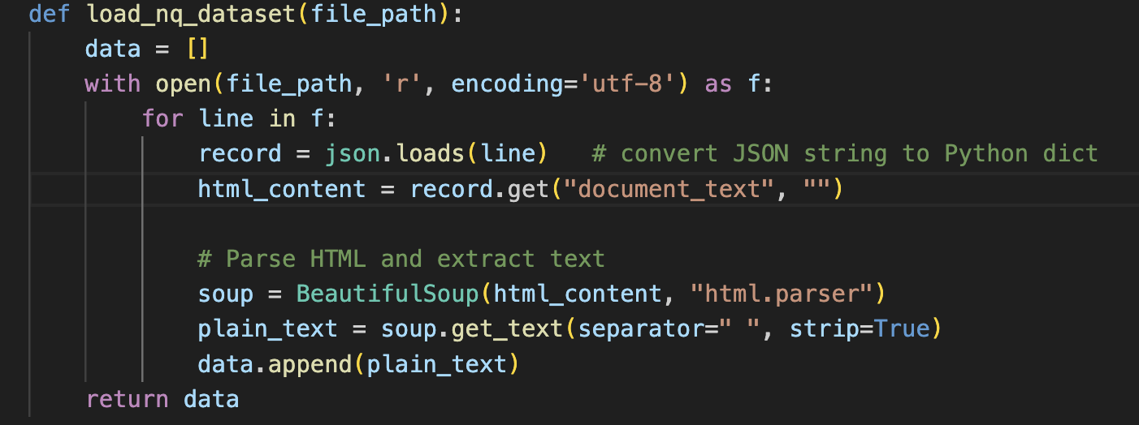
Project Deliverables
- Chunked and embedded dataset
- Notebook with RAG pipeline, retrieval, and generation
- Model leaderboard + evaluation report
- Explainability dashboard (e.g., source highlights)
- Web app/API for deployment
- README with results summary and deployment steps

How RAG Architecture Can Be Used for Q&A with NQ
The Natural Questions (NQ) dataset is particularly suited for Retrieval-Augmented Generation (RAG) in question answering (Q&A) as it features real-world search queries with contexts from Wikipedia articles, often requiring comprehension of full passages.

Key Steps in Applying RAG to NQ for Q&A:
- Data Preparation:
  - Ingest NQ's Wikipedia passages as documents. Preprocess by cleaning text and chunking into smaller segments (e.g., sentences or paragraphs) for efficient embedding
- Retrieval Phase:
  - Index chunks in a vector database (e.g., FAISS or Chroma) for semantic search.
  - For a user query (e.g., an NQ search question), retrieve top-k relevant chunks based on cosine similarity or other metrics. This handles NQ's long contexts and unanswerable questions by fetching only pertinent information.
- Augmentation and Generation Phase:
  - Augment the LLM prompt with retrieved chunks as context (e.g., "Based on this context: [chunks], answer: [query]"). Use LLMs like GPT or Llama to generate responses.
  - For long-form Q&A (as in ClapNQ extension of NQ), ensure cohesive answers by selecting non-contiguous sentences and reranking for relevance.

Technical Tags
NLP, RAG, Embeddings, Vector Databases, LLMs, LangChain, Python, HuggingFace Transformers

PROJECT DOUBT CLARIFICATION SESSION ( PROJECT AND CLASS DOUBTS)

About Session: The Project Doubt Clarification Session is a helpful resource for resolving questions and concerns about projects and class topics. It provides support in understanding project requirements, addressing code issues, and clarifying class concepts. The session

aims to enhance comprehension and provide guidance to overcome challenges effectively.

Note: Book the slot at least before 12:00 Pm on the same day

Timing: Saturday (5:00PM to 7:00PM)

Booking link :https://forms.gle/NtkQ4UV9cBV7Ac3C8

LIVE EVALUATION SESSION (CAPSTONE AND FINAL PROJECT)

About Session: The Live Evaluation Session for Capstone and Final Projects allows participants to showcase their projects and receive

real-time feedback for improvement. It assesses project quality and provides an opportunity for discussion and evaluation.

Note: This form will Open on Saturday and Sunday Only on Every Week

Timing: Monday-Saturday (11:30PM to 12:30PM)

Booking link : https://forms.gle/1m2Gsro41fLtZurRA

